Mary Barrett Reiki

Autumn Newsletter

Hello All,

Here we are now in Autumn. The Summer seemed to pass all too quickly.

This photo was taken at Little Gruinard Beach in Scotland at the end of June.

I have been enjoying my Reiki experience through the Summer, and for the first time held a Reiki Share outside by the River Avon near my home.

I have been re-reading the book ‘The Inner heart of Reiki’ by Frans Steine. It is a book I read again and again as I learn/discover something new every time. It is best to read this book when you are at Level 2 or 3 to understand some of it but as Mikao Usui taught his students different things depending on their spirituality who am I to say who should read it!

These students of Mikao Usui were people who understood that ‘ healing had to start with our heart/mind, because when our mind is clear our body and energy become clear as well’. This can only be achieved through practice of the precepts and meditation.

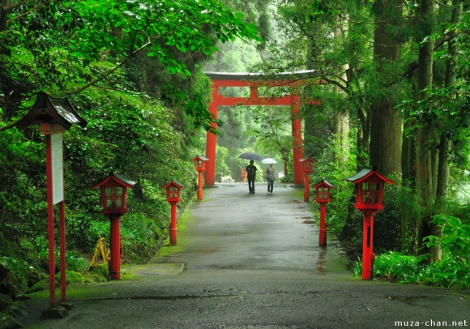

Do bear anger, for anger is an illusion
Do not be worried, for fear is a distraction
Be true to our way ad your being/True Self
Show compassion to yourself and others
Because this is the centre of Buddhahood

Feel free to email me at anytime with your questions at marybarrett204@gmail.com

Take care.

Kind Regards

Mary

